Pathfinder 2e Proficiency Calculator

Validation test

By: Jacob Herbst

Index  
Main Page Test -2

Skills Page Test – 4

Weapons and Armor Page Test - 9

Saves and Perception Page Test - 12

Main Page Test

Button testing - There should be three buttons on this page. Clicking one button should open a corresponding page. Click a button and see if it leads to correct page. Then once at next page click button labeled back in bottom left corner. This should lead back to starting page where you can test the next page. Repeat this step for all three buttons.

Skills Page Test

Untrained radio button Test – We are going to test if the program properly calculate proficiency when the untrained buttons are the only ones selected. If it works the program will display for each row a value calculated used only the proper ability score. It should not add radio button value, or level to calculation because skill is not trained. Type in all provided information and make sure only the Untrained button is selected. Then press the Calculate Proficiency Button.

Testing Values

Level = 6

Strength Modifier = 3

Dexterity = -1

Intelligence = 5

Wisdom = 2

Charisma = 4

Expected Results

Acrobatics = -1

Arcana = 5

Athletics = 3

Crafting = 5

Deception = 4

Diplomacy = 4

Intimidation = 4

Lore = 5

Medicine = 2

Nature = 2

Occultism = 5

Performance = 4

Religion = 2

Society = 5

Stealth = -1

Survival = 2

Thievery = -1

Results – The program functioned fully as intended.

Rest of radio buttons test –We will now begin to test the next columns of radio buttons . These radio buttons should also consider level because they are at least trained. The calculation should add ability score modifier, level, and then radio button value. We will run through each column of buttons and calculate results. Each column from left to right should increase value by 2 more than previous column

Testing Values

Level = 6

Strength Modifier = 3

Dexterity Modifier = -1

Intelligence Modifier = 5

Wisdom Modifier = 2

Charisma Modifier = 4

Expected Results

Acrobatics = 7 then 9 then 11 then 13

Arcana = 13 then 15 then 17 then 19

Athletics = 11 then 13 then 15 then 17

Crafting = 13 then 15 then 17 then 19

Deception = 12 then 14 then 16 then 18

Diplomacy = 12 then 14 then 16 then 18

Intimidation = 12 then 14 then 16 then 18

Lore = 13 then 15 then 17 then 19

Medicine = 10 then 12 then 14 then 16

Nature = 10 then 12 then 14 then 16

Occultism = 13 then 15 then 17 then 19

Performance = 12 then 14 then 16 then 18

Religion = 10 then 12 then 14 then 16

Society = 13 then 15 then 17 then 19

Stealth = 7 then 9 then 11 then 13

Survival = 10 then 12 then 14 then 16

Stealth = 7 then 9 then 11 then 13

Results – Program functioned as intended

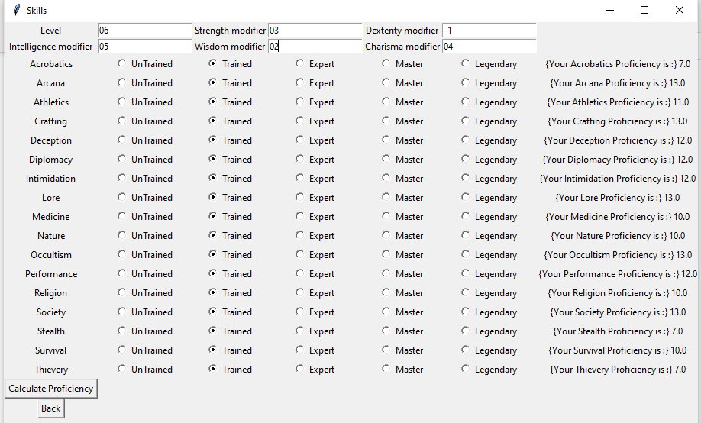

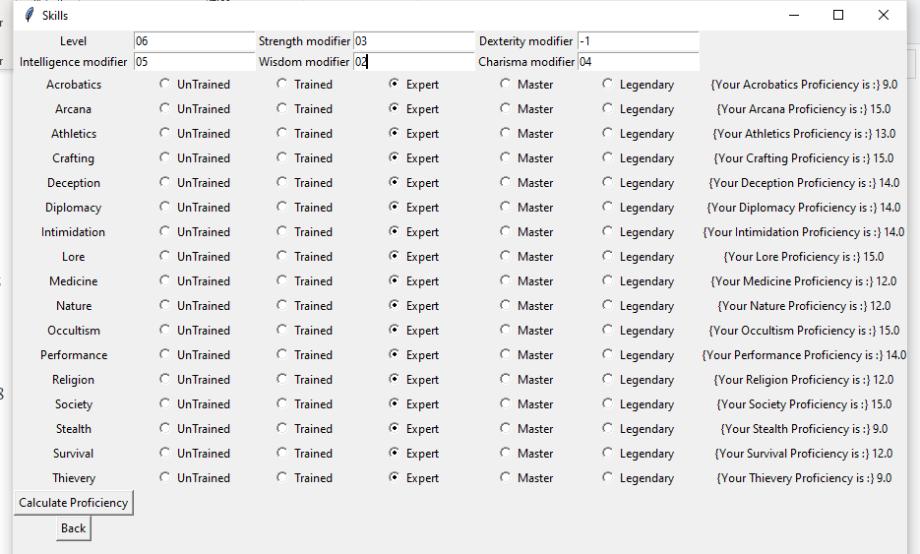

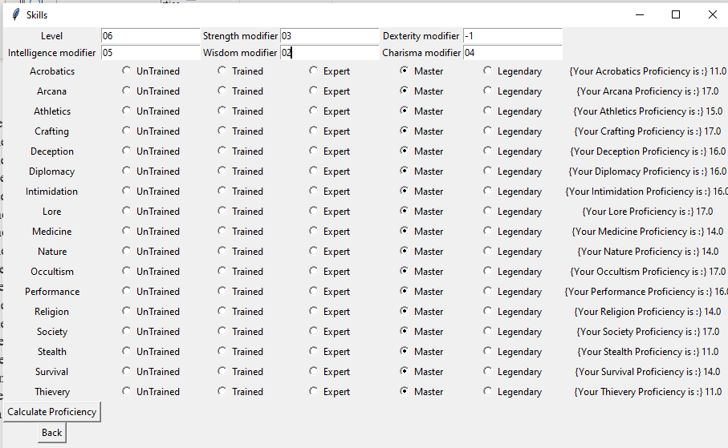

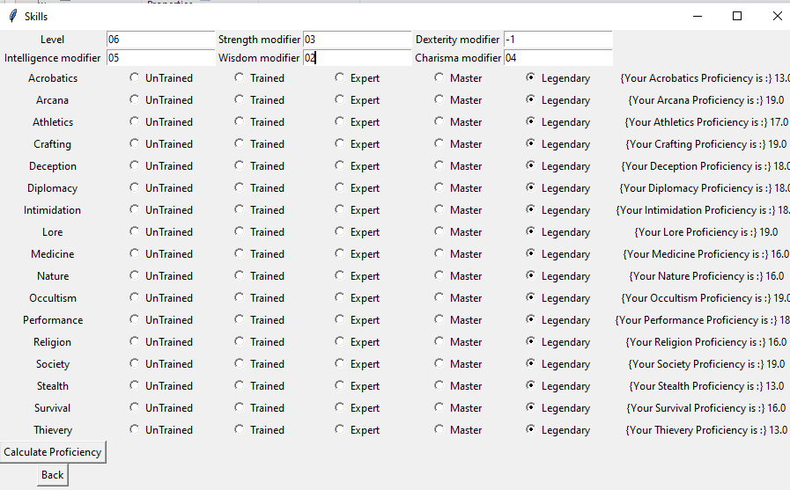

Weapons and Armor Page Test

Untrained radio button Test – For our first text we are going to test if the program properly calculate proficiency when the untrained buttons are the only one selected. If it works the program should only display 0. This is because it is not taking level into account and the radio button value is 0.

Testing Values

Level = 3

Expected Result

All proficiencies should be 0

Results – The program functioned fully as intended.

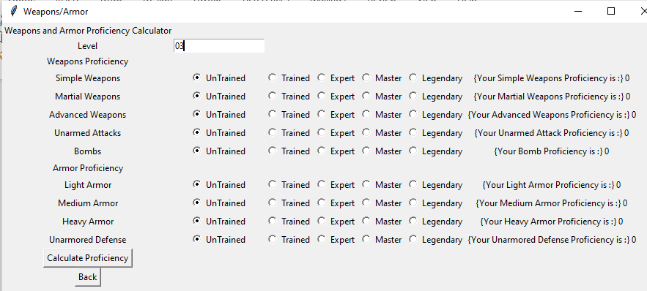

Rest of radio buttons test –We will now begin to test the next columns of radio buttons . These radio buttons should also consider level because they are at least trained. The calculation should add level and radio button value. We will run through each column of buttons and calculate results. Each column from left to right should increase value by 2 more than previous column

Testing Values

Level = 3

Expected Results

Simple Weapons = 5 then 7 then 9 then 11

Martial Weapons = 5 then 7 then 9 then 11

Advanced Weapons = 5 then 7 then 9 then 11

Unarmed Attacks = 5 then 7 then 9 then 11

Bombs = 5 then 7 then 9 then 11

Light Armor = 5 then 7 then 9 then 11

Medium Armor= 5 then 7 then 9 then 11

Heavy Armor = 5 then 7 then 9 then 11

Unarmored Defense = 5 then 7 then 9 then 11

Results – The program functioned fully as intended.

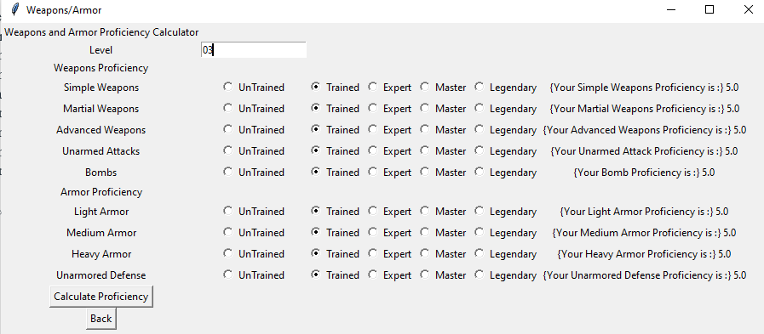

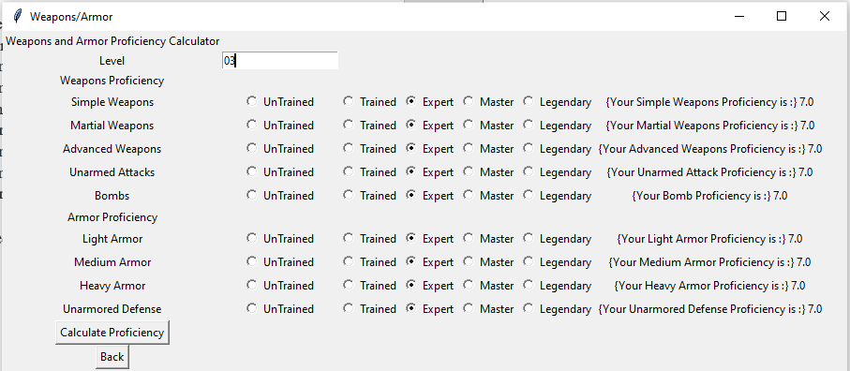

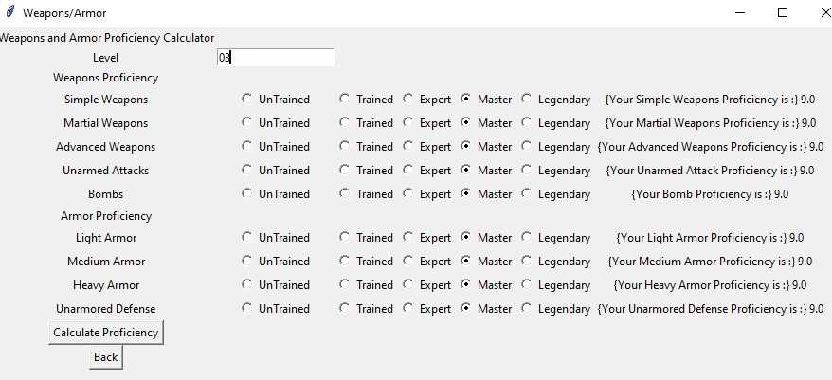

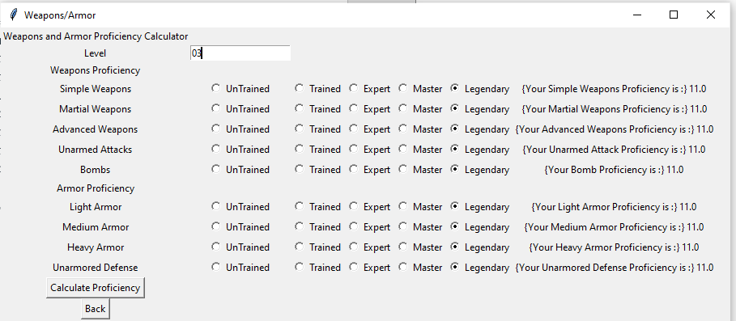

Saves and Perception Page Test

Untrained radio button Test – We are going to test if the program properly calculate proficiency when the untrained buttons are the only ones selected. If it works the program will display for each row a value calculated used only the proper ability score. It should not add radio button value, or level to calculation because skill is not trained. Type in all provided information and make sure only the Untrained button is selected. Then press the Calculate Proficiency Button.

Testing Values

Level = 4

Dexterity Modifier = 3

Constitution Modifier = -1  
Wisdom Modifier = 2

Expected Results

Reflex = 3

Fortitude = -1

Will = 2

Perception = 2

Results – The program functioned as intended

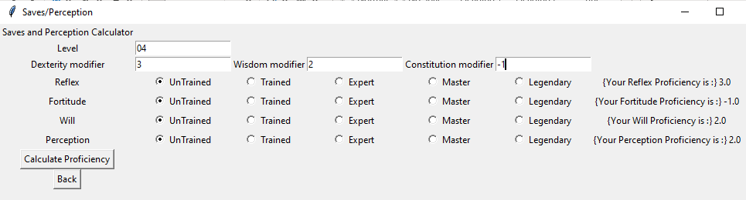

Rest of radio buttons test –We will now begin to test the next columns of radio button . These radio buttons should also consider level because they are at least trained. The calculation should add ability score modifier, level, and then radio button value. We will run through each column of buttons and calculate results. Each column from left to right should increase value by 2 more than previous column

Testing Values

Level = 4

Dexterity Modifier = 3

Wisdom Modifier = -1

Constitution Modifier = 4

Expected results

Reflex = 9 then 11 then 13 then 15

Fortitude = 10 then 12 then 14 then 16

Will = 5 then 7 then 9 then 11

Perception = 5 then 7 then 9 then 11

